

CSF3133 WEB-BASED INTERFACE DESIGN (K4)

**LAB MODULE 7**

SEMESTER III 2025/2026

PREPARED BY:

AIDA HUSNA BINTI MUHAMAD ZAIDI

NO MATRIK:

S76103

LECTURER:

TS. DR. WAN NURAL JAWAHIR BINTI HJ WAN YUSOF

LAB MODERATOR:

PN. WAN FATIN FATIHAH BINTI YAHYA

**7.1 Create a Transparent Image Text**

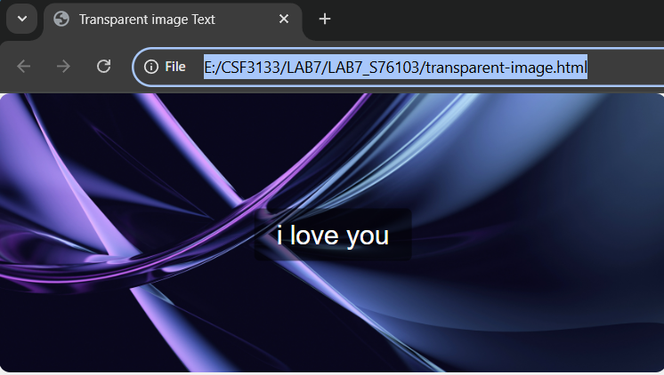

**7.2 Create a Form on Image**

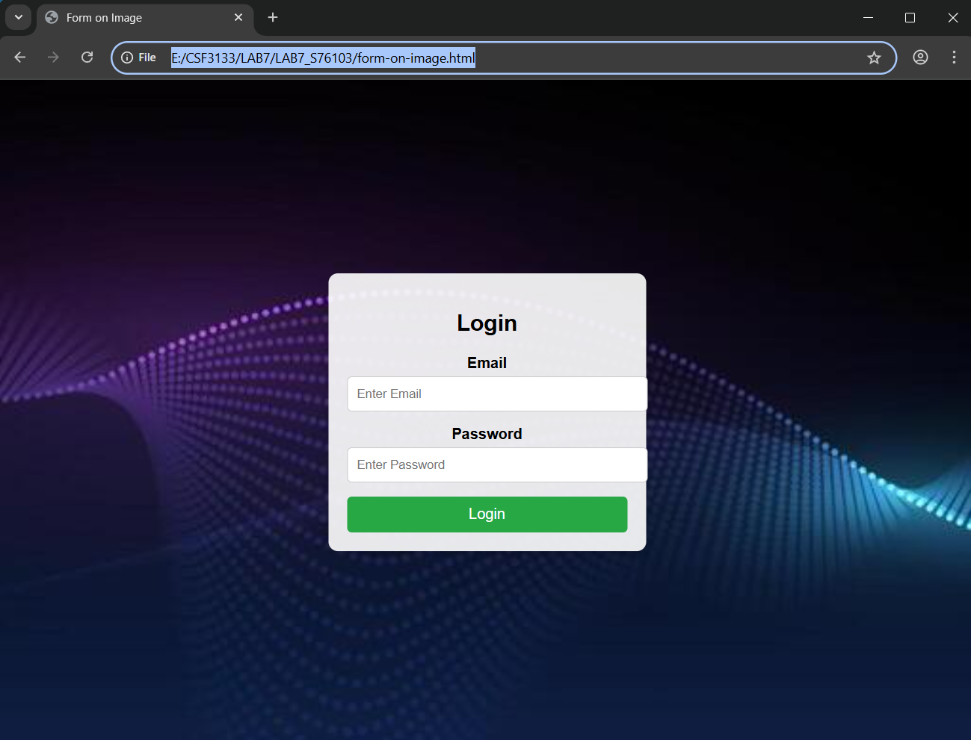

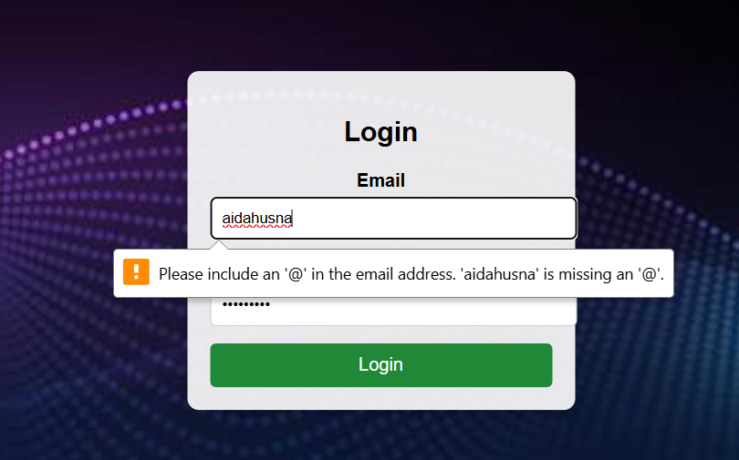

**7.3 Create a Side Navigation Buttons**

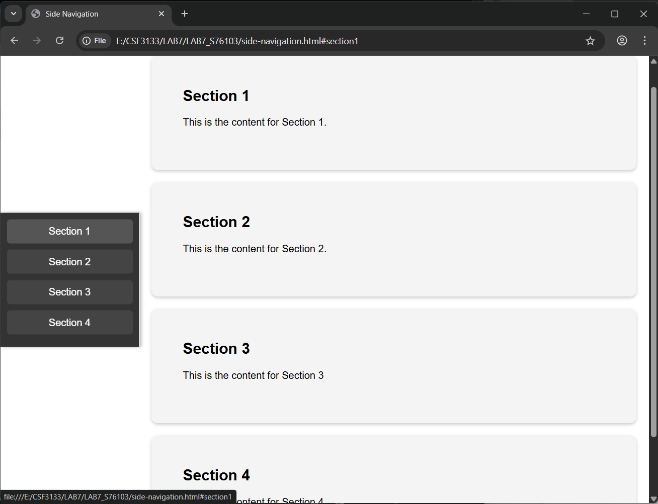

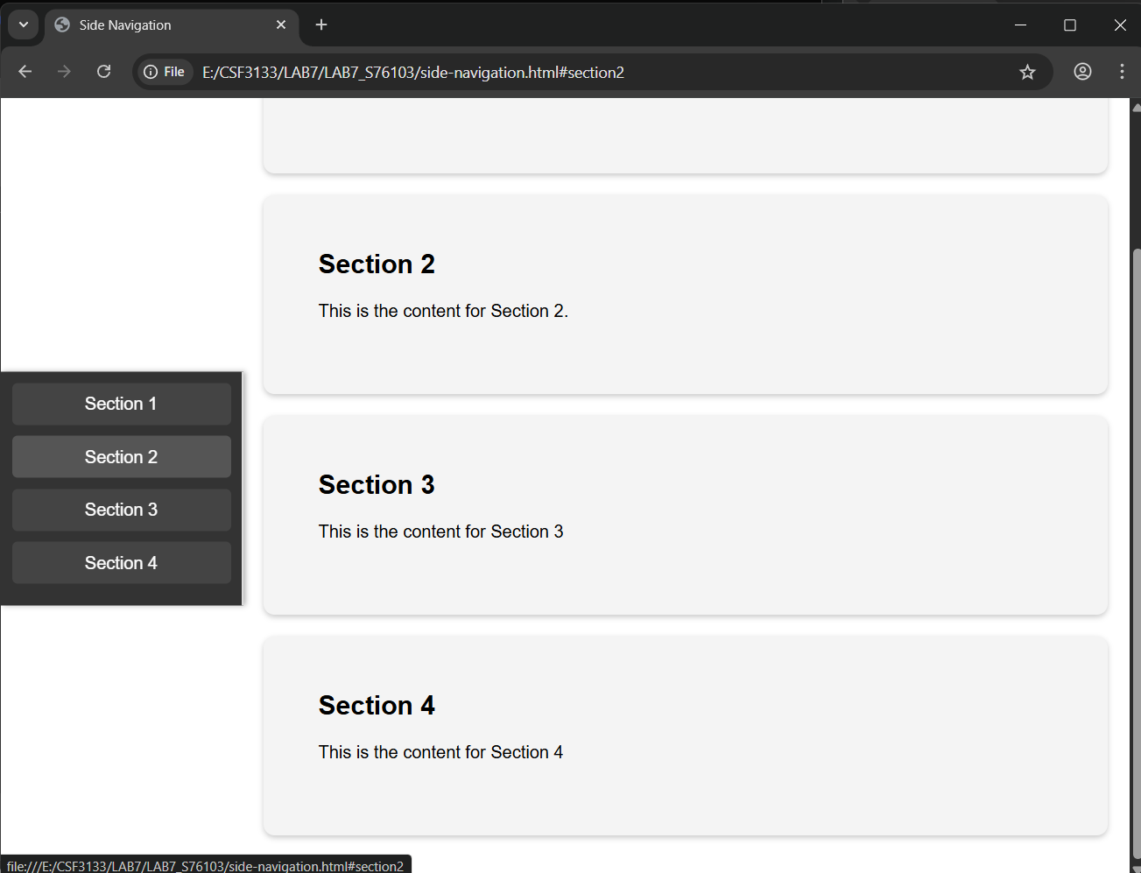

**7.4 Create Automatic Slideshow**

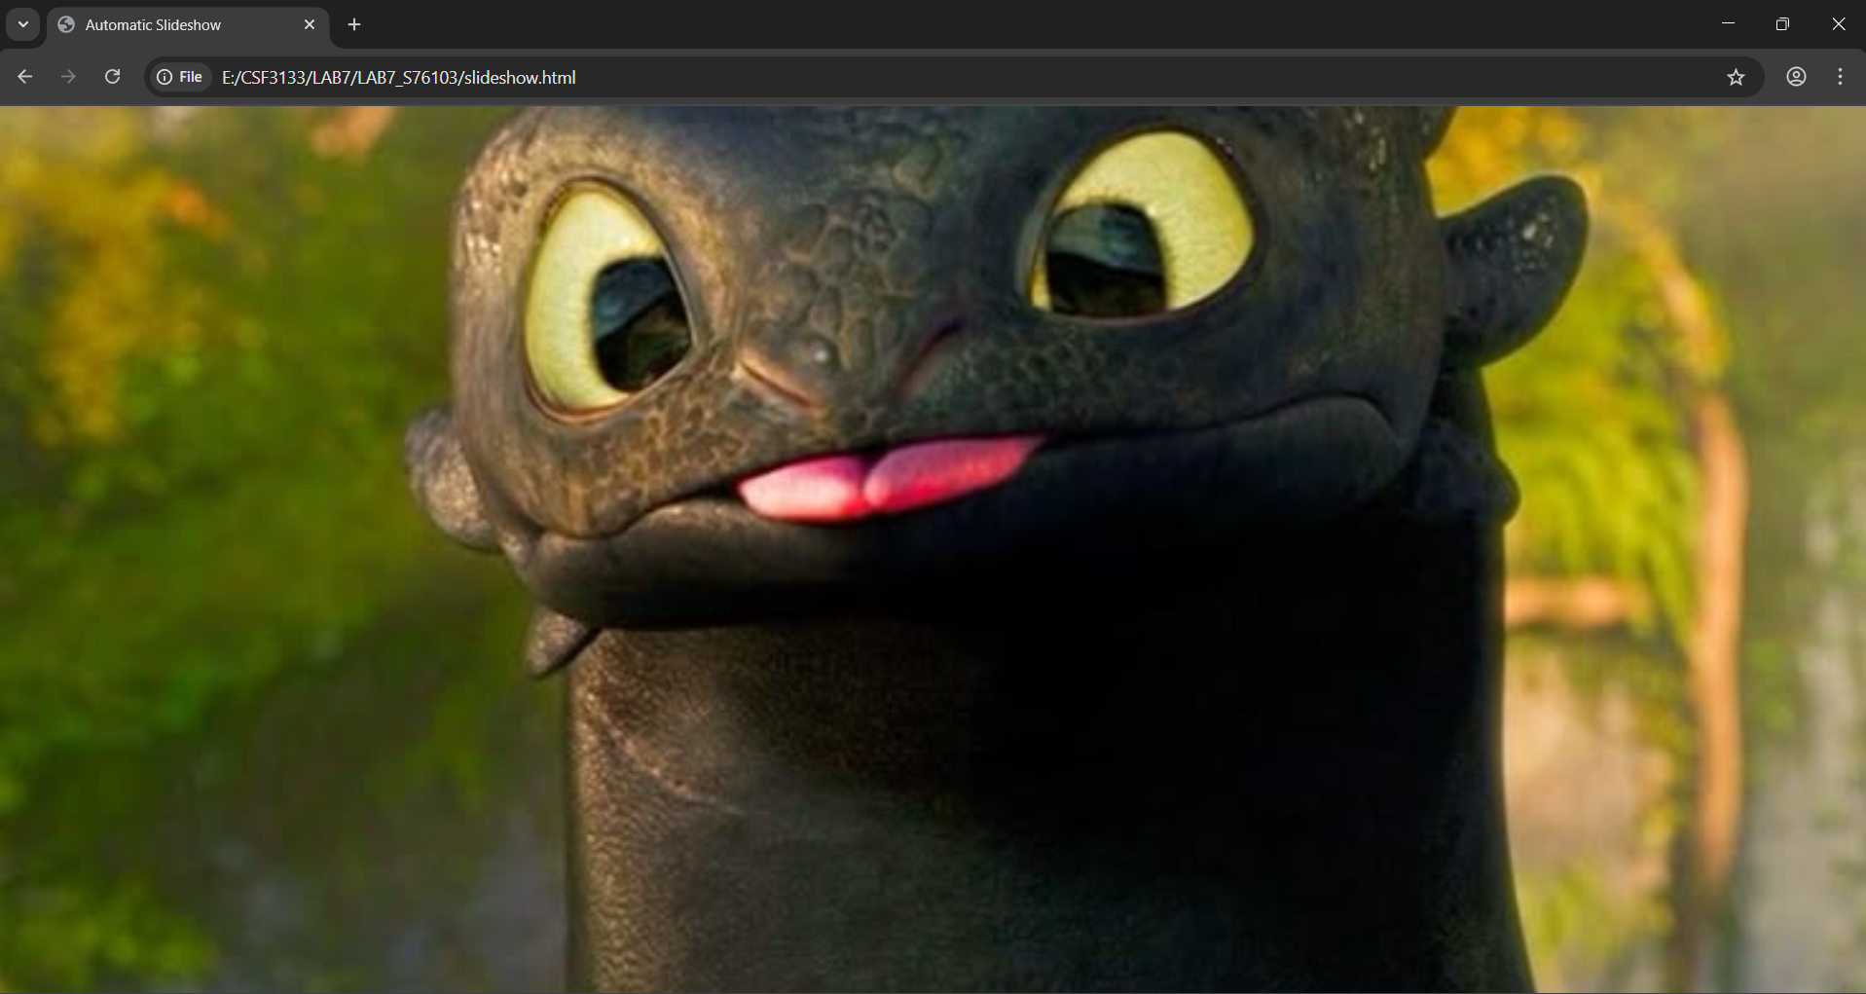

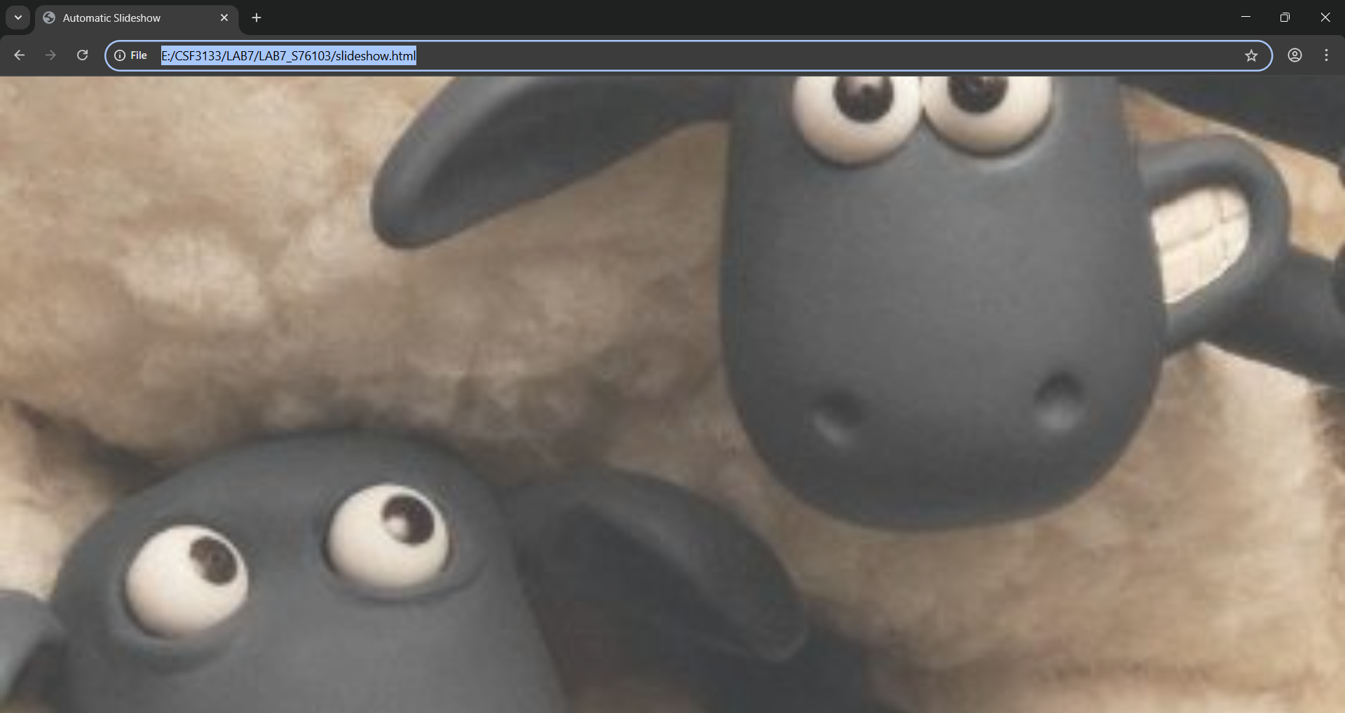

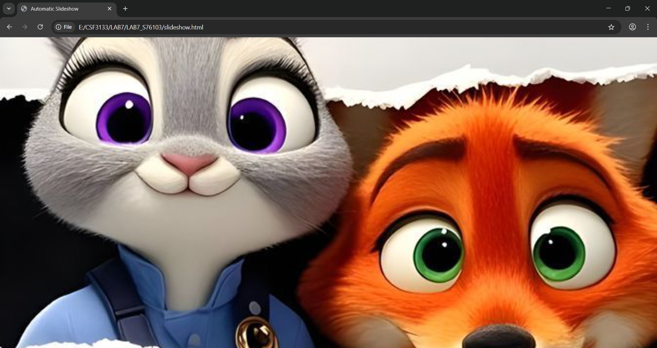

**7.5 Create Profile Card**

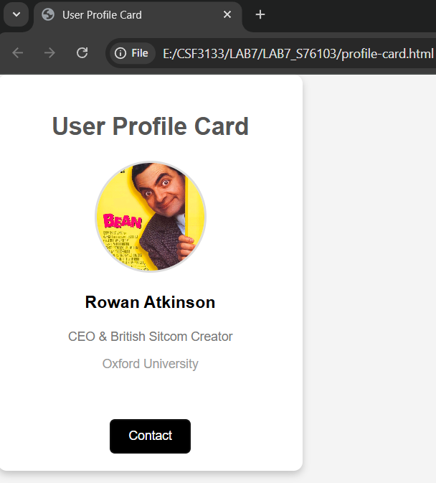

**7.6 Create Progress Bar**

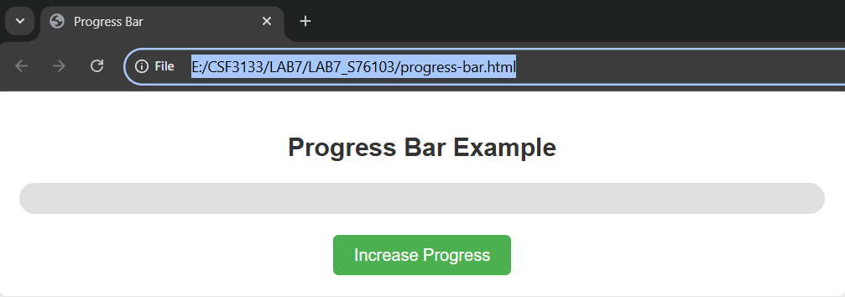

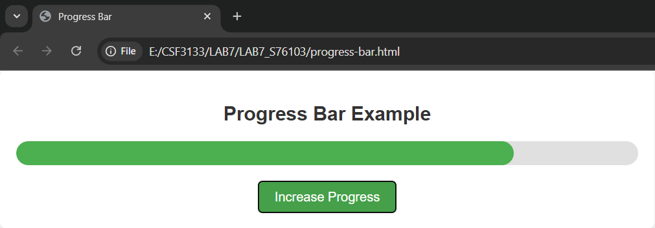

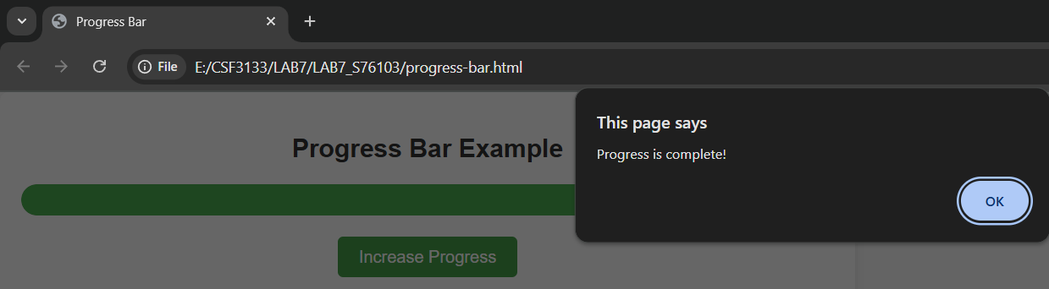

**7.7 Create A Collapsible**

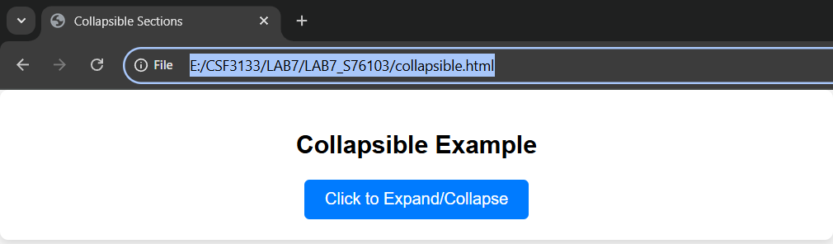

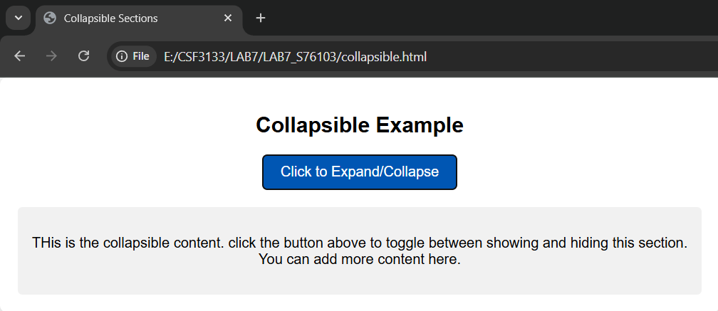

**Lab Exercise**

